Slide 1, Title Slide
RHODE ISLAND PARENTS OF BLIND AND VISUALLY IMPAIRED CHILDREN (RIPBVIC)
and
RHODE ISLAND VISION EDUCATION AND SERVICES PROGRAM (RIVESP) EDUCATORS
Represented by:
Hilary Conners, Parent
Paul Troxell, Parent
Elizabeth Doyle-Payne, M. Ed., TVI
Judi Lambert, M.Ed., MPA, COMS
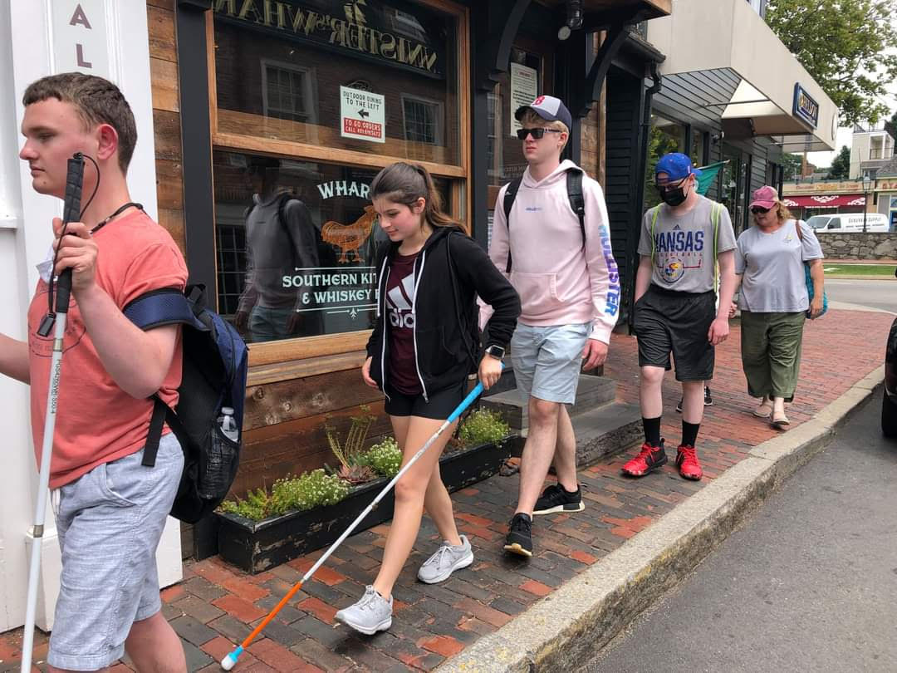

Slide 2: WHAT IS A VISUAL IMPAIRMENT?
- An impairment in vision that, even with correction, adversely affects a child’s educational performance. The term includes both partial sight and blindness, (IDEA Sec. 300.8)
- Section 1462 (c) (3) of the Individuals with Disabilities Education Act defines a low incidence disability as:
  - (A) a visual or hearing impairment, or simultaneous visual and hearing impairments;
  - (B) a significant cognitive impairment; or
  - (C) any impairment for which a small number of personnel with highly specialized skills and knowledge are needed in order for children with that impairment to receive early intervention services or a free appropriate public education. 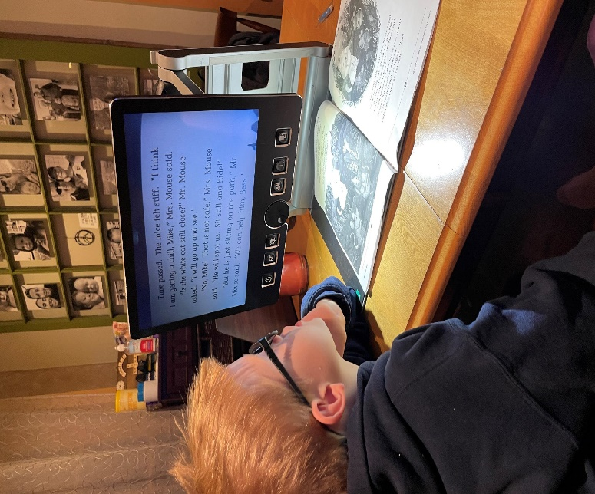

Slide 3: ABOUT TVIS AND COMS
TVIS
- School Based
*Access to Curriculum
COMS
- Home, Community & School Based
- Access to the World
BOTH:
- have graduate degrees in
- vision education
- are certified in their fields
- provide instructional and consultation services
- support children & their families from birth through 22 years of age
- instruction of specific compensatory skills
- from the Expanded Core Curriculum
The graphic on this slide is a Venn diagram showing the overlap & differences of TVI’s & COMS.

Slide 4: A DAY IN THE LIFE OF TVIS AND COMS

- TVIs and COMS provide direct instruction from Expanded Core Curriculum specific to each child’s age, ability and vision
- Provide Consultation to team members/families
- Research
- Courtesy observations
- Informal meetings or “put out fires”
- In-services
- Community outreach
- Professional agency collaboration
- Attend ophthalmologic/optometric appointments
- Review and interpret ophthalmologic/optometric reports for teams
- Evaluations
- Travel

Slide 5: RIVESP IN CRISIS
- Not Properly Funded
- Lack of Clear Leadership
- Improper Oversight
- Staffing shortage and inequities
- Lack of opportunities for program growth, community outreach and professional development
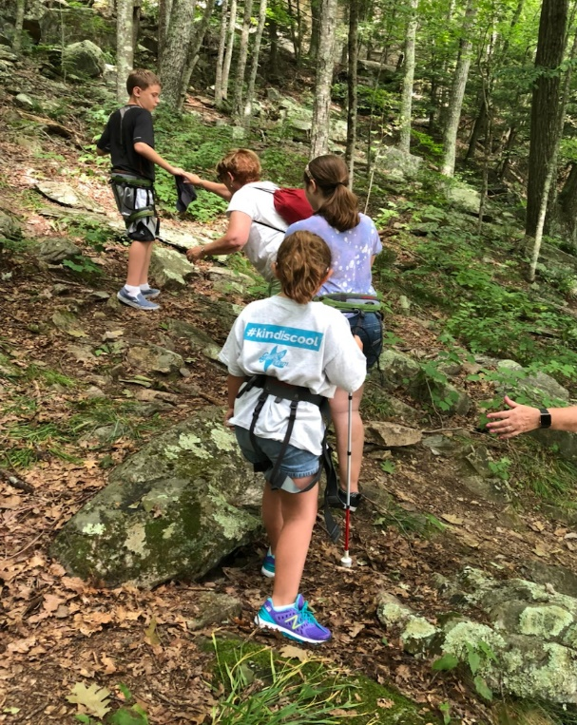

Slide 6: CURRENT FUNDING MODEL
The funding issue has been a recurrent problem. In 1976 there was a legislative commission that looked at funding these types of programs. In 2004, the Naughton led commission reviewed the RIVESP program and funding. Now in 2021, a task force has been formed to investigate the same issues.
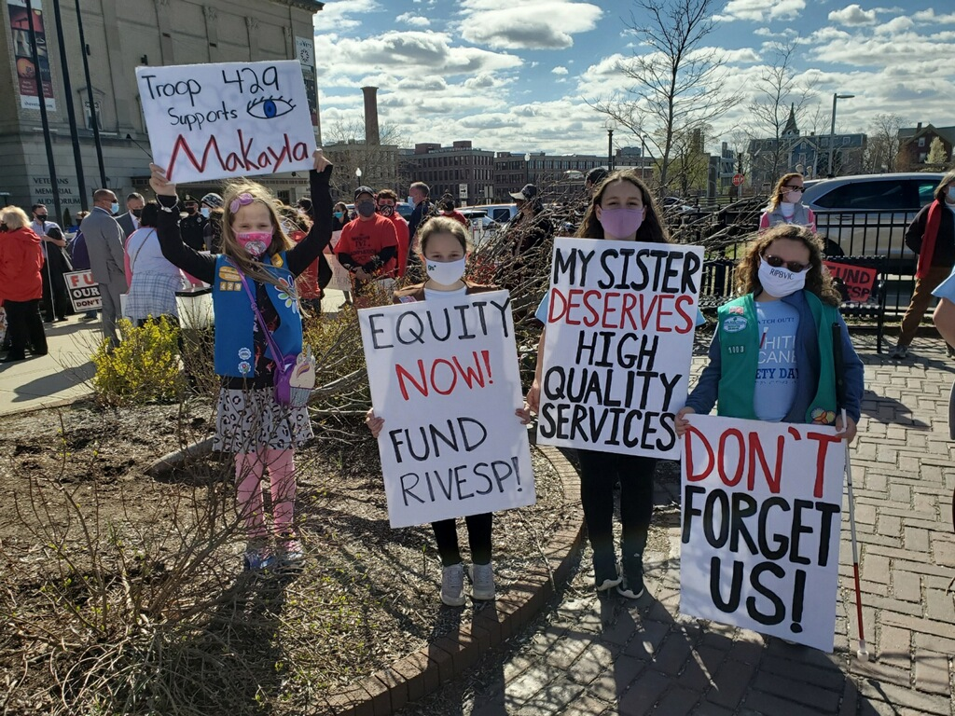

Slide 7: CURRENT FUNDING MODEL
- Only funding is $684,600 in IDEA funds plus fee for service
- Fee for service model
- Provide services to families and schools
- Does not allow for the “services” part of education and services
- Schools question service levels due to cost
- Medicaid
- Medicaid reimbursement covers a fraction of students
- Medicaid funds are used as the district determines
This slide has a graphic of a funnel with three circles inside. One circle has the text "Fee to Districts $149/hr, one circle has the text "IDEA $684,600", one circle has the text "Medicaid $???" At the bottom of the funnel is an arrow pointing down to a box with the text "RIVESP Priceles$$$$$$$$.

Slide 8: LACK OF CLEAR PROGRAM LEADERSHIP
- Current leadership is by default; director of the Sherlock Center assumes RIVESP
- Current leadership has RI College imposed restrictions to operate within, which do not support the scope and intent of RIVESP
- Current leadership must split time between multiple programs - RIVESP just one of many
  - RIVESP needs dedicated leadership versed in both vision services and student-based service management
  - RIVESP needs dedicated leadership as a liaison with districts & families

Slide 9: PROGRAM LEADERSHIP SOLUTIONS
- A separate executive director for RIVESP with a background and knowledge of vision services. Director must be:
  - Well versed in the Expanded Core Curriculum
  - Well versed in impacts of specific visual impairments on student education
  - Well versed in how additional disabilities impact student education, function, and personal success
  - Well versed in how ethnic, cultural, and socio-economic backgrounds impact service provision and receptiveness of student needs
  - Well versed in the needs of vision service providers

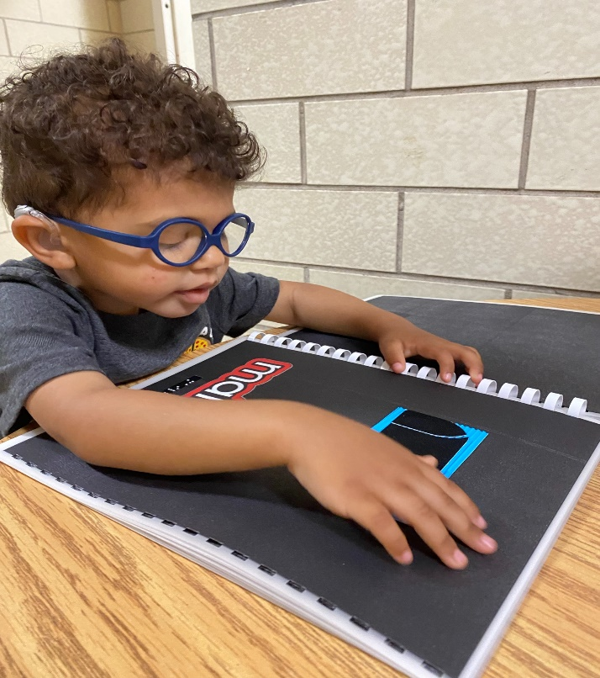

Slide 10: IMPROPER OVERSIGHT
- Lack of cohesive oversight –
- DOA, RIC, RIDE decisions about RIVESP are made without a functional understanding of vision services and the program needs
- DOA, RIC, RIDE decisions should not be based on a dollar amount. Education is not a business. Students, families, and schools are our partners not customers.
- Disjointed oversight interrupts productivity, as service providers are required to provide information to different entities
The graphic used on this slide has a circle with the text “RIVESP,” there are three squares with arrows pointing down at RIVESP, the text in each square is “RIC”, “DOA”, “RIDE.” To the bottom right is a square by itself with text inside, “Advisory Board.”

Slide 11: THE OVERSIGHT SOLUTION
- RIVESP Advisory Board
  - An educated and invested Advisory Board allows for clear focus and expectations to complete the mission of the final report
  - Advisory Board will provide recommendations to RIVESP as detailed in the RI General Law 16-26.1
  - The RIVESP executive director reports to advisory board
  - RIVESP executive director is responsible for day-to-day operations and management
  - Advisory Board will communicate program needs or concerns with RIDE
- The graphic on this page is flow chart. At the top is the Advisory Board with the text, “Approves and Monitors Budget,” “Oversees Entire Program.” Underneath the Advisory Board is the RIVESP Executive Director with the text, “Oversees Day to Day Operations,” “Reports directly to Advisory Board.” Underneath the RIVESP Executive Director are the RIVESP Service Providers with the text, “Provides Statewide Services.”

Slide 12: STAFFING SHORTAGE AND INEQUITIES
- Staffing numbers previously reported are inaccurate
- 2005 Final Report states RIVESP needs a minimum of 15 service providers – 2021 we do not have this.
- Quality providers should not be dictated by budget management
- RI only state with compensation discrepancy between school based TVIs and COMS
- Using outdated means of recruitment
- RIC’s hiring practices not appropriate with RIVESP needs
- Recent staff changes & caseload distribution have resulted in referrals not being addressed
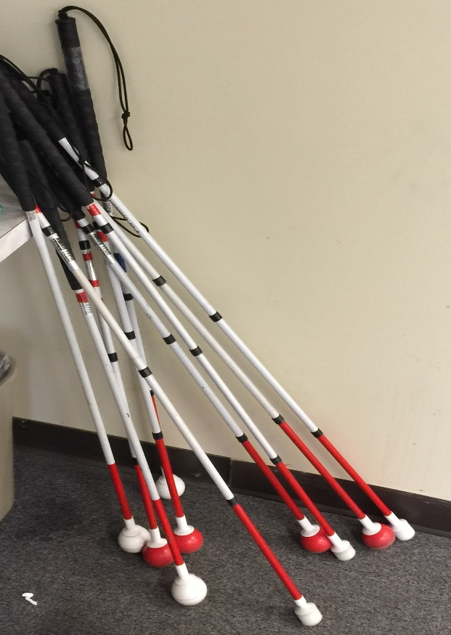

Slide 13: STAFFING SOLUTIONS
- Offer competitive wages and benefits package for ALL providers
- Offer sign on incentives
- Create long term recruitment and retention plans
  - Providers with diverse cultural and linguistic backgrounds
  - High school recruitment
  - Teaching Programs
  - Establish plans to support qualified staff with varied abilities
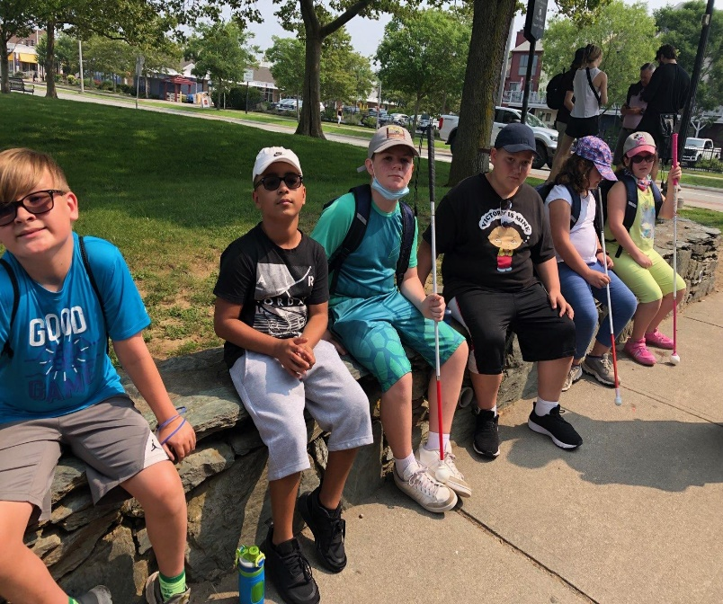

Slide 14: PROGRAM GROWTH PROBLEMS
Currently there is a lack of opportunity for program growth, collaboration, community outreach and appropriate professional development
- This is the “services” portion of RIVESP as outlined in the final report
- This program was meant to service the whole state
- Lack of meaningful professional development
- Due to current funding, lack of oversight, and lack of staff, these opportunities are unable to be pursued

Slide 15: PROGRAM GROWTH
For this program to grow as it was intended, there needs to be:
- Opportunity to implement extracurricular activities and workshops
- Collaboration with community partners
- Time and staffing for effective instruction within the federally mandated Expanded Core Curriculum
- Integration of EI vision services into RIVESP
- Staff evaluations by professionals with experience in vision services
- Time for professional development relevant to disciplines
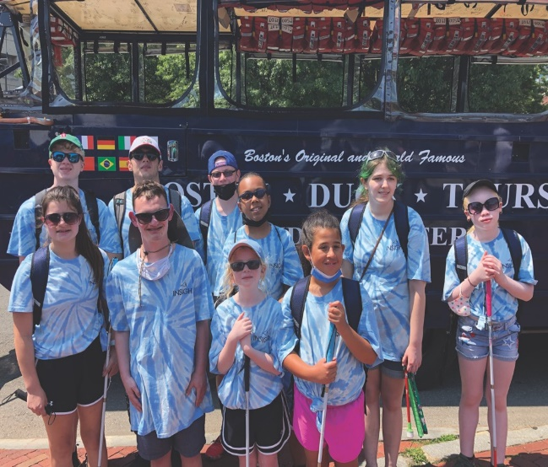

Slide 16: THE FUNDING SOLUTION
- Full legislative funding for the program will:
  - Eliminate fee for service to alleviate financial burden on school districts
  - Allow Increased collaboration with school districts
  - Allow for continued collaboration with families without district
  - interference
  - Allow for creation of programs addressing Expanded Core Curriculum,
  - as required by law
  - Allow for greater access to professional development to maintain and
  - increase best practices
  - Allow for increasing community collaborations and outreach
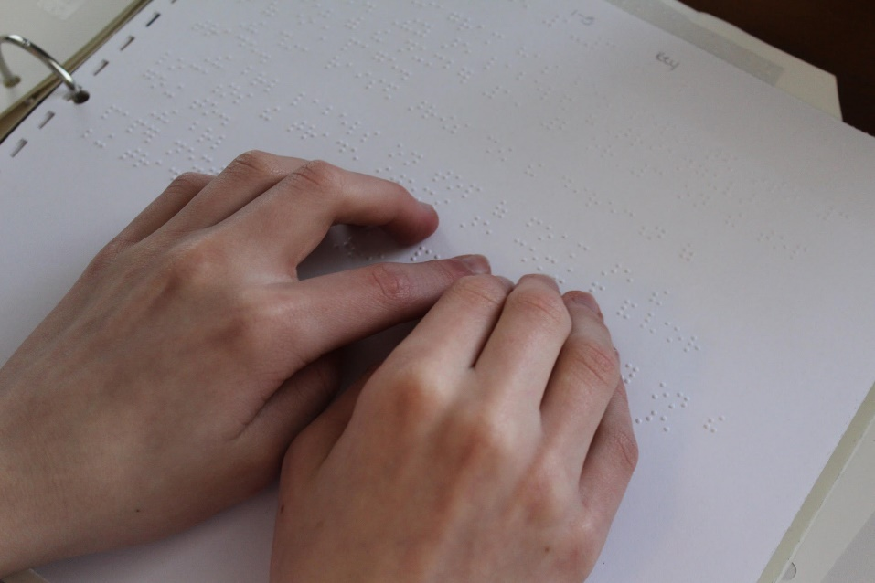

Slide17: IF WE HAD A MAGIC WAND…
- RIVESP would be a state agency with leadership experienced in the field of visual impairment
- RIVESP Certified Orientation & Mobility Specialists would be compensated equally as Teachers of Students with Visual Impairments and would become Howard Union of Teachers members
- RIVESP would have an allowance for growth to develop programs for our students, families, and communities addressing the many areas of the Expanded Core Curriculum
- RIVESP would be fully funded, and districts could anticipate that their students with visual impairments would have high quality Free and Appropriate Public Education
- RIVESP would have regular, meaningful vision related professional development
- RIVESP would provide outreach to local colleges – presenting class sessions, recruiting, (so there is a next generation of providers)
The graphic on this page is an animated wand with stars and sparkles.

Slide 18: ALONE WE CAN DO SO LITTLE; TOGETHER WE CAN DO SO MUCH.
-HELEN KELLER

